Background

Big Mountain Resort is a ski resort located in Montana with views of Glacier Forest and Flathead National Forest. The number of visitors per season is an average of 350,000 people, with the visitors skiing for an average of five days. There are 11 lifts, and 1 magic carpet for beginners. The resort has recently installed a new lift that increases operating costs by $1.54M this season. The resort's pricing strategy has been to charge a premium above the average price of resorts in its market segment. Visitors value some facilities more than others, which is not good business sense. The ski resort is considering recommendations for cutting costs without undermining the ticket price, and recommendations to support higher ticket prices.

Suggestions

The business has shortlisted the following 4 options:

1. Permanently closing down up to 10 of the least used runs. This doesn't impact any other resort statistics.
2. Increase the vertical drop by adding a run to a point 150 feet lower down but requiring the installation of an additional chair lift to bring skiers back up, without additional snow making coverage
3. Same as number 2, but adding 2 acres of snow making cover
4. Increase the longest run by 0.2 mile to boast 3.5 miles length, requiring an additional snow making coverage of 4 acres

Scenarios

All 4 scenarios were modeled on a ticket price predicator based on the above options

**Scenario 1- Close up to 10 of the least used runs**

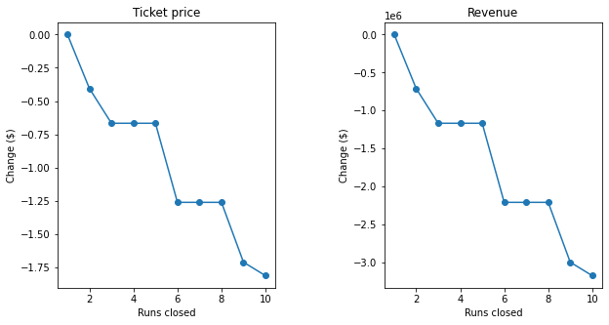

Closing one run makes no difference. Closing 2 and 3 runs reduces support for ticket price and so revenue. Increasing the closures down to 6 or more leads to a large drop.

**Scenario 2- Increase the vertical drop by adding a run to a point 150 feet lower down but requiring the installation of an additional chair**

Increases support for ticket price by $8.61. Over the season, this could be expected to amount to $15065471

**Scenario 3- Report of 2, but adding 2 acres of snow making**

This increases support for ticket price by $9.9. 0Over the season, this could be expected to amount to $17322717. Small increase in the snow making area makes no difference.

**Scenario 4-  Increase the longest run by .2 miles and guaranteeing its snow coverage by adding 4 acres of snow making capability.**

Makes no difference